**Leader Overview**

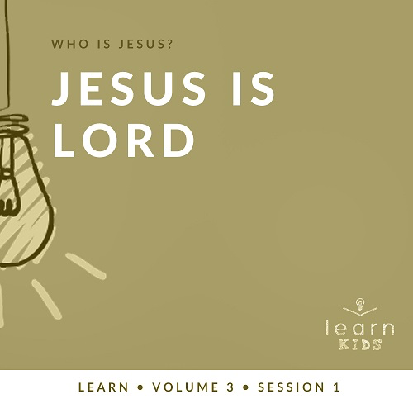

**Volume Overview**

**Who is Jesus?**

*In the classic book* Mere Christianity*, C. S. Lewis reasoned that those who refuse to believe Jesus’ claim to be God are left with the option of labeling Him as a lunatic or the devil. Jesus asked His closest followers who people thought He was (*[*Matthew 16:13*](https://ref.ly/logosref/Bible.Mt16.13)*). The disciples responded with far-ranging opinions. But then Jesus turned the question on them: “Who do you say I am?” Two thousand years later, there may not be a more important question for any of us to answer*.

**Session Overview**

**Jesus Is Lord**

*In our Bible story, Jesus enters Jerusalem for the final week before His death. By this point, many have heard about His incredible miracles and healings. He fulfills prophecy by entering the city on a donkey, and He’s met by people who worship Him. This Triumphal Entry was different from most Roman leaders at the time who used their military to show their power. Jesus shows that He does things very differently, but He is still the Lord of our life*.

**Bible Lesson**

Jesus’ Triumphal Entry

[Mark 11:1–11](https://ref.ly/logosref/Bible.Mk11.1-11)

**Faith Fact**

I will follow Jesus.

**Faith Verse**

[John 3:16](https://ref.ly/logosref/Bible.Jn3.16) (NLT)

“For this is how God loved the world: He gave his one and only Son, so that everyone who believes in him will not perish but have eternal life.”

**Preparing for the Session**

**Leader Preparation Time: 20–25 Minutes**

|  |
| --- |
| ***You Will Need***  ***Large Group***  *• Bible*  *• Worship songs (Song suggestions: “Real Love” by Hillsong Young and Free; “This Is Amazing Grace” by Phil Wickham; “Good Father” by Chris Tomlin)*  *• For groups not using a phone or tablet only, add:*  *• Projector or TV*  *• Laptop*  *•* ***Faith Fact Slide***  *•* ***Faith Verse Video*** *or* ***Slide***  *•* ***Bible Lesson Video***  *•* ***Teaching Point Slides 1–3***  *• Smartphone*  ***Small Group***  *• Blindfold, one for each pair of kids*  *• Bibles for kids in your group to share*  *•* ***Small Group Faith Verse Review****, one set per team*  *• Scissors*  *•* ***Small Group Activity Page****, one per kid*  *• Pencils or pens, one per kid*  *• Bandanna*  *To access session content and videos from a computer, visit:* [*BibleEngagementProject.com/downloads*](https://bibleengagementproject.com/Downloads) |
| ***Getting Ready***  ***Large Group***  *• Download videos and slides if needed.*  *• Select worship song(s) and have them ready to play.*  *• Print/familiarize yourself with the Simon Says list or prepare other creative actions*  ***Small Group***  *• Optional: Set up activities or an obstacle course for the kids to navigate through.*  *• Print the* ***Faith Verse Review*** *pages 1 and 2, one set per team. Cut apart the boxes.*  *• Print copies of the* ***Small Group Activity Page****, one per kid.*  *First time leading* Learn *for Kids? Check out the* [Facilitator Guide](https://0b769b0ed3569ef9d18b-f88d8272f61086866d50d048b43ef630.ssl.cf2.rackcdn.com/sites/biblengagementproject/Listen_Facilitator_Guide.pdf). |

**Large Group**

**30 Minutes**

*See what’s needed at the beginning of the session.*

**Introduction**

Welcome! I’m so glad you’re here. Today, we’ll learn about the most important Person in the whole Bible, and His name is Jesus. He has several titles in the Bible, too. One of them is the King of kings. Pretty cool, right? What do you think about when you hear the word *king*? *(Allow responses.)* I think about knights or soldiers who follow their king and protect or serve him.

**Faith Fact**

Today, we’ll talk all about what it looks like to follow Jesus, the King of kings. Our Faith Fact for today is **I will follow Jesus**. We’ll learn a bit about the kind of king Jesus is and why following Him is the best thing we can do.

• *Show the* ***Faith Fact Slide***.



Let’s stand up and march while we say it. **I will follow Jesus.** Keep marching. Can you shout it? **I will follow Jesus.** Let’s wave our hands in praise. **I will follow Jesus.**

**Game**

**Extreme Simon Says**

In order to follow Jesus, we need to pay attention to who He is and the words He says. That way we won’t miss out on any direction He might give. Let’s practice our listening and following skills with a game of Extreme Simon Says.

You may have played this game before. Normally, whoever is leading will say something like, “Simon says touch your nose” or “Hop up and down.” You follow the instructions only when what they say starts with Simon Says.

• *If the leader says, “Simon says” followed by an action, then the kids must follow*.

• *If the leader says an action without “Simon says,” then the action must not be followed. If someone does follow, they are out and should sit down*.

That game can be really fun, but I have some extreme actions for us to follow today.

Listen carefully, so you can follow what I say. Let’s play!

• *Play multiple rounds if you have time*.

• *Here is a list of suggested actions for the game*.

• Play air guitar

• Roll over

• Waddle like a penguin

• Rub your tummy and pat your head at the same time

• Pretend to be a beautiful butterfly

• Cry like a baby

• Pretend to climb a ladder

• Wiggle your nose

• Do whatever your friend does

• Smell your feet

• Start singing

• Hug yourself

• Walk backwards

• Walk on your knees

• Act like a monkey

• Wink with your left eye

• Yawn

• Stand on one foot

• Shout, “Hosanna!”

Great job, everyone. I think you’re getting the hang of following the leader.

**Worship**

In our Bible story today, we’ll hear how people praised Jesus. Let’s worship Him together now by singing.

• *Lead the kids in singing one or two praise songs. See suggestions at the beginning of the session*.

**Bible Lesson**

Thanks for worshipping with me today. Now, let’s get ready to look at God’s Word. In our story today, Jesus made His big entrance into the city called Jerusalem. If you were to make a grand entrance at your school, a sports game, or a party, what would it look like? *(Allow responses.)*

That’s awesome! In our story today, Jesus, the most important person ever, is about to make His grand entrance. Remember, we can always learn something from God’s Word, so let’s pray and ask God to help us learn from this story today.

**Prayer**

|  |
| --- |
| Dear God, please help us learn from Your Word today. Help us to see the kind of king Jesus is and show us why and how we should follow Him. Amen. |

**Video Intro**

Before we get started with the Bible story, let’s watch this video and check in with Dash.

• *Play* ***Bible Lesson Video***.

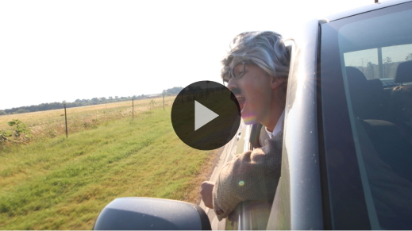

**Bible Story**

**Jesus’ Triumphal Entry**

That’s such a fun lead-in to our Bible story today! Earlier we talked about how we would make a dazzling entrance, and your ideas were great. Remember how we said Jesus is the King of kings? What do you think an entrance for someone like that should look like? *(Allow responses.)* What actually happened may surprise you. Jesus’ entrance wasn’t exactly what we might think a kingly arrival should look like. Let’s check it out!

Grab your Bible or pull up a Bible app on your device. Turn to [Mark 11:1–11](https://ref.ly/logosref/Bible.Mk11.1-11).

• *Read the Bible story aloud to the group*.

• *In order to keep Large Group time moving along, we don’t recommend having the kids read*.

• *Optional: Remind the kids to mark this place with their Bible Bookmark, so they can read it on their own at home*.

**Teaching Time**

|  |
| --- |
| ***You Will Need***  *• Smartphone*  *No prep needed for this activity.* |

Wow, that’s not the entrance for a king like I imagined, but it shows us a lot about the kind of king Jesus is. What do you think we can learn from how Jesus entered the city? *(Allow responses.)* Jesus certainly was coming to be the king, but not in the way the people in that day were used to.

We have the choice to follow Jesus today, and this story helps us see what it’s like to follow Jesus. Remember our Faith Fact today? Let’s say that together one more time. **I will follow Jesus.**

**1. Jesus is the ruler of my life.**

• *Show the* ***Teaching Point 1 Slide***.

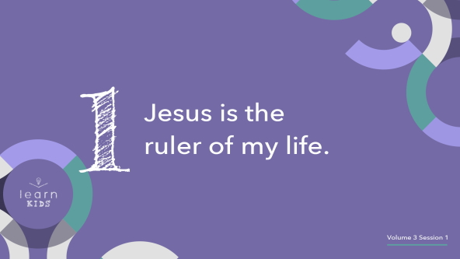

• *Choose two volunteers to act out this scene*.

When Jesus entered Jerusalem, some other people were there who were in charge of the city and surrounding land. They were called the Romans, and they had a huge empire. The leader of the Romans during that time was called Caesar. *(Pick one of the volunteers to be Caesar.)* Many Romans believed that the Caesar was lord over everything. *(Say to the volunteer.)* Caesar, give us a couple commands to make sure everyone is following you.

• *Commands might include having everyone stand up and jump, everyone clap twice, etc*.

Now even though the Caesar may have been in charge of that city, Jesus is the one who really was in charge. *(Point to the other volunteer.)*

It’s the same for our life today. We all go to lots of places that have someone who’s in charge of it. Who’s the person in charge of your school? *(Allow responses.)* Who’s the person in charge of your city? *(Allow responses.)* Who’s in charge at your house? *(Allow responses.)* Who is the person in charge of our country? *(Allow responses.)*

Many different people are in charge of things we do every day. They have the responsibility to rule over it, kind of like a king or queen. We also need to listen to whoever is leading us, like our teachers at school or a doctor giving advice. No matter who’s in charge, whether it’s a manager at a store or a general in an army, Christians know that ultimately Jesus is the ruler of their life.

This means that following Jesus is more important than following anyone else. More important than following our friends or even our favorite YouTubers! Of course, we should respect our parents and leaders in our communities, but we know we follow the King whose Word we follow over anyone else: Jesus. That’s what our Faith Fact reminds us of. Let’s say it together. **I will follow Jesus.** Thanks for your help.

• *Have the kid who is playing Caesar sit down*.

**2. Jesus is different from other rulers.**

• *Show the* ***Teaching Point 2 Slide***.

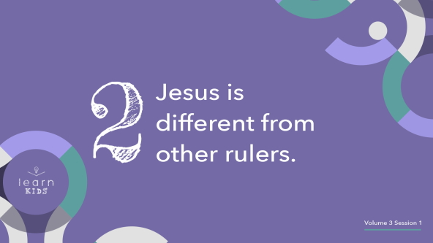

Everyone, close your eyes. I want you to imagine a strong, powerful king or queen. They have many soldiers, loyal followers, and lots of influence. Now, imagine a servant in the castle who does lowly tasks and is unnoticed and unimpressive. Who would you rather follow? *(Allow responses.)* The people in Jesus’ day wanted to follow a strong ruler. Jesus had some other plans in mind. He served people. How do you think Jesus might be serving if He were here right now? *(Allow responses.)*

• *Have the kid who is playing Jesus follow what the kids suggest if possible*.

Remember how we talked about how a king would enter a city? In Jesus’ day, the Romans often marched into cities with soldiers to show power. They had a lot of fancy things to show how rich they were. Then, there’s Jesus. He rode in on a donkey without much else happening. This was not the kind of king the people were expecting, so it confused them. Some of those people who didn’t understand decided they didn’t want to follow Jesus.

Those who did understand knew that Jesus was a different kind of ruler. He was kind, compassionate, and helped those who were hurting. That’s why they decided to follow Him. Thanks for your help.

• *Have the kid who is playing Jesus sit down*.

**3. Jesus deserves our worship.**

• *Show the* ***Teaching Point 3 Slide***.

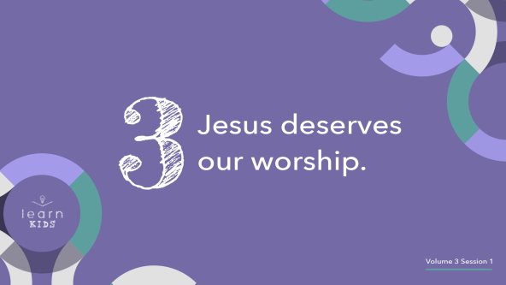

When Jesus entered the city, those who saw Him as their Lord worshipped Him. They showed Jesus they loved Him by laying down their coats to make a path for Him. They honored Jesus with their words and their actions. Jesus was important to them, so they made sure that they showed it with their worship.

We can do this every day, too. When something is important to us, we show it with our words and actions.

• *Pull out a smartphone*.

Many people today show that these are important to them. They spend a lot of time on the phone and make sure it are safe by putting protective cases on it. They’ll talk about the latest games they play or videos they’ve seen. What people do and what they talk about show what’s important to them.

If Jesus is important to us, then we’ll show it in our words and actions. We’ll use our words to worship Jesus. We’ll share His story with others. We’ll use our actions to help others, to give to those in need, and to show love. We’ll spend time trying to get closer to Him by reading the Bible and praying. If we’re going to follow Jesus, then we should know that He deserves our worship.

**Prayer and Response**

*Consider playing a worship song softly in the background while kids pray*.

Do you want to follow Jesus? If you’ve never made that decision to follow Jesus before, today can be your day to decide that. If you’ve already made that choice before, then you have a special assignment. You should help other people know about Jesus so that they can follow Him, too.

We’re going to take some time and ask God what our next step should be from today’s teaching—to choose to follow Jesus or to help others learn about Him. Everyone, bow your head, close your eyes, and let’s ask God to speak to us about how He wants us to follow Jesus.

|  |
| --- |
| Dear God, we open our heart and mind to You so we can hear You today. Amen. |

• *Allow some time to pass*.

Now, I want to invite you to pray with a leader about what God spoke to you or about any other need you have today.

• *Take time to pray with kids*.

I really hope that you heard something from God about how He wants you to follow. If you didn’t, don’t worry. God speaks to us in many ways and at different times. Hearing His voice is something we can practice.

**Prayer**

• *Optional: Have the kids repeat phrases of the prayer after you*.

|  |
| --- |
| Dear God, thank You for sending Jesus to be our King. May we all listen for Your leading and choose to follow You. Amen. |

**Faith Verse**

Our Faith Verse reminds us that God loves us so much that He sent Jesus to give us eternal life. We can gladly follow Jesus because we know He cares for us.

• *Play* ***Faith Verse Video***.

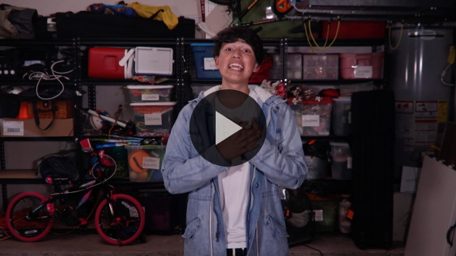

[John 3:16](https://ref.ly/logosref/Bible.Jn3.16) (NLT)

“For this is how God loved the world: He gave his one and only Son, so that everyone who believes in him will not perish but have eternal life.”

Knowing that God loves us makes it really easy for us to want to follow Jesus. When we follow Him, we know that we have hope to be with God forever in heaven.

**Faith Fact**

Before we go to our small groups, let’s review our Faith Fact again.

• *Show the* ***Faith Fact Slide***.



Say it with me. **I will follow Jesus.** I know you can do it! It’s been great learning with you today!

• *Dismiss kids to Small Group time or to go home if your group time ends here*.

**Small Group**

**30 Minutes**

*This section can be done in conjunction with the large group or on its own if you do small groups with your kids. During Small Group time, the goal is to connect the kids with the Word of God and to each other. All activities are led by the small group leader.*

**Group Connection**

**Blind Follower**

|  |
| --- |
| ***You Will Need***  *• Blindfold, one for each pair of kids*  ***Getting Ready***  *• Optional: Set up activities or an obstacle course for the kids to navigate through.* |

We’re going to play a game that requires really good listening so you can follow the directions. You’ll work together in pairs. One person will wear a blindfold while their partner gives them directions. You’ll need to listen carefully so that you can accomplish whatever your partner asks you to do.

• *After a few minutes, have the partners switch roles*.

Which was easier—leading or following *(Allow responses.)* It can be like that when we follow Jesus, too. We need to practice until it gets easy for us to hear His voice and to obey Him. Say our Faith Fact with me. **I will follow Jesus.** I’m confident that He will help us to do that.

**Learn about It**

|  |
| --- |
| ***You Will Need***  *• Bibles for kids in your group to share*  *No prep needed for this activity.* |

**Scripture Search:** [**John 13:12–15**](https://ref.ly/logosref/Bible.Jn13.12-15)**;** [**Matthew 7:21–23**](https://ref.ly/logosref/Bible.Mt7.21-23)**;** [**Matthew 16:13–20**](https://ref.ly/logosref/Bible.Mt16.13-20)

Let’s dig deeper into God’s Word and see what else we can learn about Jesus. As we find and read each of these verses, let’s consider: What does this Scripture mean for our life today?

• *Give each kid a Bible and search for one or more of the Scriptures as a group together (as time allows). When everyone has found the Scripture, have one of the kids read it. Then, answer the question about it*.

• *Pair kids who need additional help with older kids or start simple and look up the session’s Bible story Scripture:* [*Mark 11:1–11*](https://ref.ly/logosref/Bible.Mk11.1-11)*. Kids will get better finding Scriptures the more they practice*.

• *Optional: Make this a competition to see who can find the Scripture first*.

**Bible Reading Tip**

God’s Word is so good. There’s a lot of great stuff in it that we can use every single day. One way to make sure we get the most out of it is by memorizing verses that mean a lot to us. Then, you can remember them any time you need some encouragement. Sometimes, finding a verse that you want to memorize can be hard. Other times, doing the work to memorize is what makes it hard. Don’t give up on it.

**Challenge**

Here’s a challenge for you this week. Use your Bible or Bible app to find a verse that sticks out to you or choose our Faith Verse: [John 3:16](https://ref.ly/logosref/Bible.Jn3.16). Then, spend some time writing it or saying it to yourself three times a day until you memorize it.

**Faith Fact**

All of our Bible reading is a reminder to me of our Faith Fact. Say it with me: **I will follow Jesus.**

**Group Discussion**

*Feel free to use all or just a few questions as a jumping-off place for good discussion. Questions marked with * are designed for more conversation. Adjust the questions based on the age or maturity of your group. Typically, older kids will be able to dive a little deeper than younger ones*.

**Questions**

• *If small group activities are not immediately following large group time, you may want to read the Bible story passage before this discussion*.

What did the people do when Jesus rode into the city?

Why did the people respond the way they did?

* What does it mean to have Jesus be the King in your life?

* How do we honor other leaders in our life and still honor Jesus the most?

How is Jesus different from others who lead us?

* What do you like the most about the kind of ruler Jesus is?

Why do you think Jesus deserves our worship?

* What are ways we can worship Jesus?

* What’s something specific you can do this week to follow Jesus?

**Prayer Requests**

*Finish group discussion by sharing prayer requests and praise reports. Keep track of your small group’s prayer requests and review them each time you meet. Have kids pray for each other’s prayer requests*.

**Prayer**

*Have kids pray for each other’s prayer requests*.

**Faith Verse Review**

|  |
| --- |
| ***You Will Need***  *•* ***Faith Verse Review****, pages 1 and 2, one set per team*  ***Getting Ready***  *• Print the* ***Faith Verse Review*** *pages 1 and 2, one set per team. Cut apart the boxes.* |

Our Faith Verse today is [John 3:16](https://ref.ly/logosref/Bible.Jn3.16). It tells us that we know God loved us because He sent Jesus to give each one of us eternal life. Anyone who believes in Jesus can have it. Let’s watch the Faith Verse video and do the actions together.

• *Show* ***Faith Verse Video***.



[John 3:16](https://ref.ly/logosref/Bible.Jn3.16) (NLT)

“For this is how God loved the world: He gave his one and only Son, so that everyone who believes in him will not perish but have eternal life.”

**Faith Verse Fun**

**Scripture Scramble**

Our Faith Verse is one that is very important to keep in our heart. Let’s practice by unscrambling it together. Pay attention, because after we do it once together, we’ll split up into teams and see which team can finish first. Then, we’ll work together as a team to see how fast we can unscramble it.

• *Work together to see the fastest times for the group together and for teams*.

**Activity Page**

**Hidden Message**

|  |
| --- |
| ***You Will Need***  *•* ***Small Group Activity Page****, one per kid*  *• Crayons*  ***Getting Ready***  *• Print copies of the* ***Small Group Activity Page****, one per kid.* |

Jesus is the most important part of our world. We should try to follow Him as best as we can. If we are, then we need to help others see why following Him is so important.

• *Give each kid a copy of the* ***Small Group Activity Page*** *and crayons*.

Since we’re practicing following, let’s see if you can follow the instructions to discover something God wants us to do.

**Dismissal**

I’m so glad you were here to learn about God with me today. Let’s close in prayer.

**Prayer**

|  |
| --- |
| Dear God, thank You for sending Jesus to be a leader that we can be glad to follow. Help us to listen to Your Word and to worship You. Amen. |

**Faith Fact Recap**

• *Show the* ***Faith Fact Slide***.



One important thing I want you to remember from today is our Faith Fact. Let’s say it together one more time. **I will follow Jesus**. I’m glad you came today. I can’t wait to see you next time.

• *Send home the* ***Small Group Activity Page***.

• *Remind parents that there are* ***Family Devotions*** *available on the app to do with their kid*.

• *Tell everyone the date and time for the next session*.